

CZ3005 Artificial Intelligence

Lab Assignment 3

Zilvinas Skuodys

N1902489E

Question 3: Subway interactor

This assignment required to build a subway order interactor based on prolog. Customer shall be offered selection of foods/ingredients based on meal type he selects.

Interface is created on python, implemented in **mysubway.py**, to run the program just run this file.

# Database initialization and defining relationships in prolog:

In the **mysubway.pl** I pre-defined option choices for the interactor.

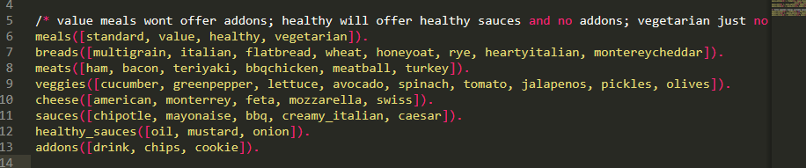

Further, I have defined variables that will attribute previously defined variables to different categories. *Meat_choice, sauce_choice, addons_choice*are different from the others because they do some filtering on what variables to return depending on the meal choosing.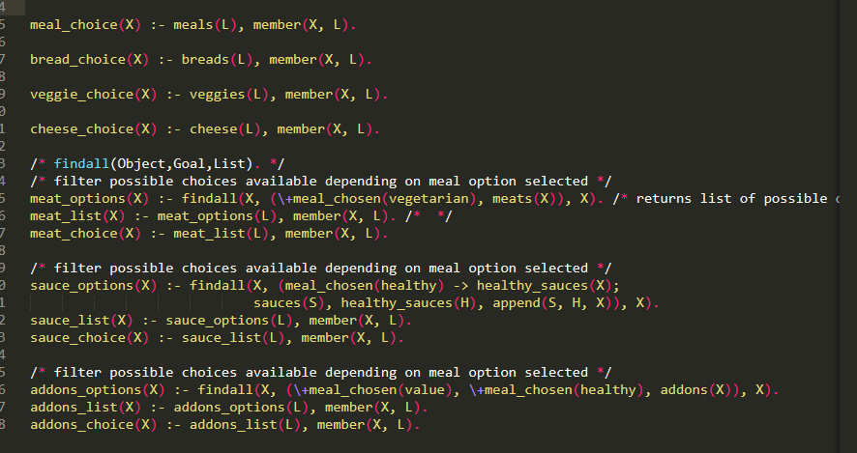

The program itself runs in a predefined order: start -> choose meal -> choose bread -> choose meat -> choose vegetables -> choose cheese -> choose sauce -> choose addons

In between there are questions if the user is ready to pick an item or wants to skip that choice, some choices like picking meal or bread cannot be skipped.

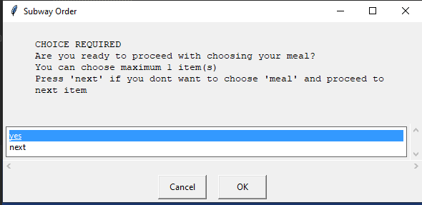

Once user is ready to pick a choice he is then prompted to another window where he sees a list of options that he can pick, also if it is not important ingredient user can press ‘next’ to skip it and choose another ingredient.

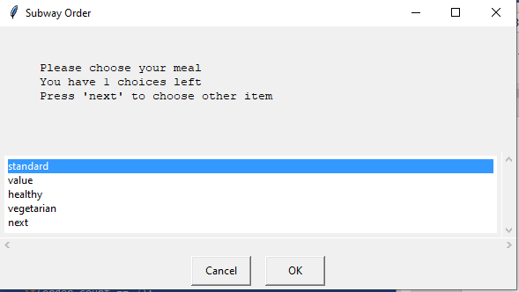

There are 4 different types of meals:

* Standard – user is offered to choose from all possible options available
* Value – user will not be offered to choose addons
* Healthy – user will be offered different sauce options and will not be offered addons
* Vegetarian – user will not be offered to choose meat

User not being offered means that the window for that choice will not display in the choice sequence entirely. For healthy meal choice only healthy sauce options will be displayed. When all the ingredients are selected they will be printed out in the console, if there is some ingredient that was skipped or not chosen by the user ‘NA’ will be displayed’

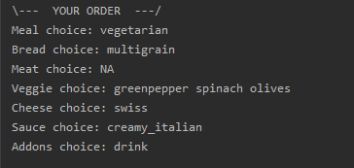

The entire program is run by keeping a sequence number counter for the order, this way we know what should go next. 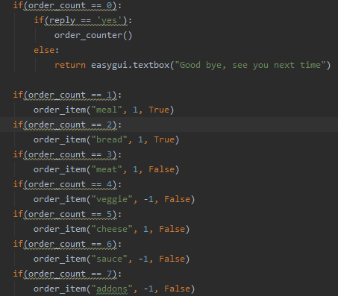

Order_item takes 3 parameters:

* ***­item_name*** defining name of the item to be chosen
* **max_count** maximum number of ingredients that can be picked, -1 if unlimited
* **choice_required** Boolean variable defining if choice for this ingredient is required

Further we go into ordering every specific item, we retrieve a list of available items and pass it on to another function *ask_wanted* that prompts user a question if he wants to choose that ingredient. If choice is required user will only be let go forward if he selects ‘yes’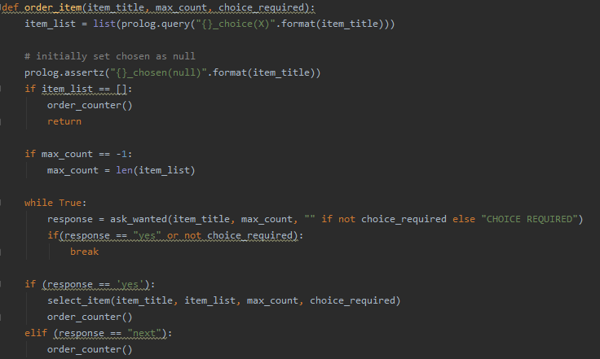

When user progresses through the window asking if he wants to choose that ingredient he is then prompted to another window with all choices available where he will have to pick his response. **Ask_choice** function being just a helper function to display the window for all the ingredients available. As user selects ingredients, those choices that allow more than 1 choice, will remove chosen ingredient from the list and will display a new updated list of possibilities.

